ECE Capstone Project
Home Automation

Aaron Pettit
aaron.pettit@comcast.net

5/1/2019

Table of Contents
Table of Contents 1
1. Executive Summary 2
2. Introduction 3
3. Design Features 3
3.1. Server 3
3.2. Android Application 5
3.3. Home Controller 7
3.4. Lighting Controller 7
3.5. Washer Dryer Controller 8
3.6. Communication 9
4. Results 10
4.1. Application 10
4.2. Home Controller 11
4.3. Lighting Controller 11
4.4. Washer Dryer Controller 11
5. Discussion 12
6. Conclusion 13
References 15

Executive Summary
This document contains information about a home automation system allowing a user to control their lights and know the status of their laundry machines using an app on their android phone. A general application flow is shown, and a detailed explanation is given on how the phone app functions. An explanation is provided on the external Application Programming Interface (API) used in the project that made the system run smoother for the user.
Implementation of the hardware is covered and how all the systems work together to create a home network. Details on how the communication system helps counter the random noise that can be created in this wireless system. A diagram is shown how data is formatted to reduce this noise.
An overview of the testing for this system is shown and there is a discussion on why some failing tests do not affect the performance of the system. The major failing test for the system about the communication system is discussed and how it affects all the controllers that use the system.

Introduction
The goal of this project is to create a simple home automation system controllable from the user’s phone. The main piece of automation I wanted to create was a way to send a notification to my phone when the washer or dryer is finished. There could be ways to get into the wiring of the machines to directly detect when the machine stops, but I wanted to make a device that could work on any machine. An induction coil could be looped around the power cable for the machines; however, this may not be an easy solution for a customer.
I decided to attach vibration sensors to the back of the laundry machines using magnets. Magnets allow users to place the sensors wherever they want if the surface is metallic. This makes installation very easy and should work on any machine.
The way the system is currently designed, additional types of automation systems can be added to the user’s home. For this project, the ability to control lights was added to the functionality of the system. Additional functionality was added to the lighting system giving user more customization over light names and using a timer.
The end product of this system allows a user to receive status updates on their laundry machines and control the lighting in their home from anywhere they are in the world as long as they have an internet connection.

Design Features

Server
The database used is Google’s Firebase real-time database. This database is hosted online by google and has several APIs that lets the app communicate with the server. Three APIs used for the system are as follows: Authentication, Real-time Database, and Admin. The Authentication API allows a user to log in and have an account to save data. The Realtime Database API holds the data and notifies any listeners of changes. The Admin API is similar to the Realtime API, but can be run in a non-app context.
The database is setup to only allow reads and writes to authorized sections of the database. The user can only read and modify data for their own system. The database is structured to have two sections: Users and Systems.
The User section contains the unique ID (UID) for each person connecting their google account to the application. Each user stores their system ID and if washer and dryer notifications are enabled.
The Systems section contains all the data for each system split up into two categories Lighting and Washer Dryer. The Lighting sections contains information for each light and stores the following information: active state, name, timer active, timer start, timer end, and light ID. The Washer Dryer section contains the status of each of the machines.

Android Application
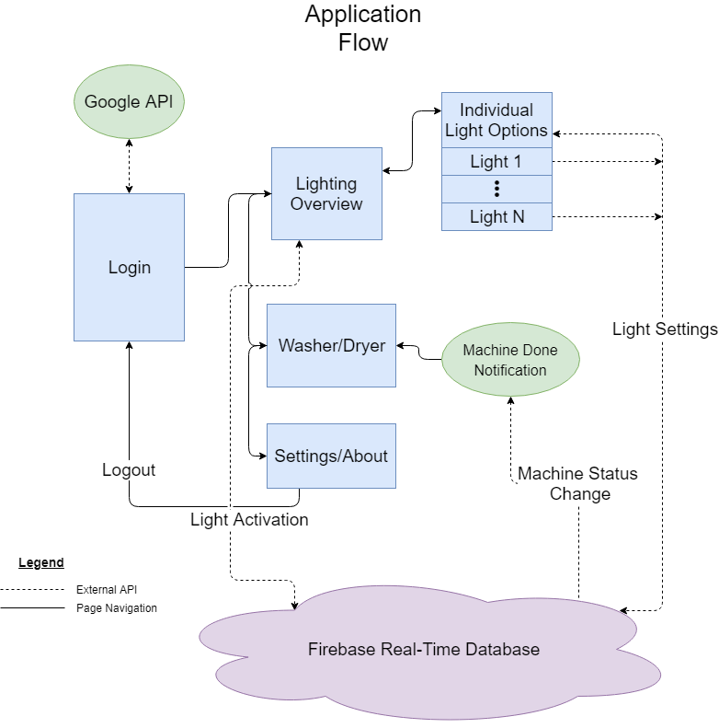
Figure 1 Android application flow diagram
The application only runs on android devices running android API of 22 or newer which is android Lollipop 5.1. Running on this android version will support approximately 85.4% of android devices [1]. The language used to program the application is Java.
The login screen initially had the user enter a username and password to enter the system. As the system ID was already unique, only a username would need to be created. Instead of the user making a custom account for this app, the Google login API was used. This allows the user to connect their google account to the app and some of the user’s settings can be stored.
If the user has previously logged in, the system ID associated with their account is retrieved and automatically filled out, then the user just needs to press log in. If the user has not associated their Google account with the app, they may do so, or just enter the system ID manually. The system ID is only stored if the user uses a Google account.
After logging in, the user may navigate between the Lighting, Washer Dryer, and Settings pages.
The Lighting page contains an overview of all the system lights and allows the user to turn each light on and off using a switch. The layout is setup to dynamically create the number of lights contained in the server. Additional options for each light may be accessed allowing the user to set the name of a light and enable a timer. The user may set a start and stop time for the timer, or the default times are for sunrise and sunset.
The Washer Dryer page displays the current status of the machines. A stopwatch icon is used to tell the user if an alert is set for a specific machine. The user may toggle this setting and this is stored under their Google account on the server so it may carry over between sessions.
The Settings page contains the system ID and the ability to log out. The system ID is un-editable but allows the user to know the system ID if needed without looking at their home controller. The log out button will bring the user back to the login screen and remove their Google account from the server’s database.
A database class is used to manage data from the database for the app. Whenever a value changes in the database, an alert is sent out to any function listening for that data or any of its parents. These listener functions will then update the app data appropriately. Specifically, for the washer and dryer, once the status has changed from active to idle, a notification is created to notify the user of the change.
The challenge when dealing with the database is the asynchronous behavior. Taking asynchronous behavior into account, the app will continue to run normally not waiting for the data unless necessary. This will prevent the app from becoming unresponsive while I’m waiting for the data. The app proceeds as if the operation succeeded; but, if the server validation failed, then error handling will occur. An example of this is when first logging into the app. The server may not have retrieved all the lighting data so the light display will be empty. Once the data from the server has been obtained, the screen shall update with the new information.
To test the application, the server data can be opened on a browser and the app open on a phone. Verify the data on the phone matches the data in the server when values change in either the app or the server. When logging out of the app, verify the user’s data is erased in the server.

Home Controller
The home controller is a Raspberry PI 3 using a Riorand 3400 433MHz transmitter and receiver. Firebase Admin is used to retrieve the data without making an application. The language used is Java, as the Firebase Admin API does not work with C/C++.
The home controller will listen for changes in a light’s status in the database. When a change has been detected, a byte will be sent in the format (device_type(1) light_id(6) status(1)). The device type for lighting is a 1. For example, to turn on light6, 10001101 (0x8D) is sent.
The home controller receives transmission data from the washer/dryer controller in the format (device_type(1) zeros(5) washerStatus(1) dryerStatus(1)) where device_type is 0. The database is then updated with the new washer and dryer statuses.

Lighting Controller
The micro controller used is the TM4C123GH6PM and the receiver is the Riorand 3400 433MHz. To power the micro controller, the light switch must be replaced with a light switch with a USB outlet. The power box must be at least 2 Gage to fit all the components inside. A JQC-3FF 120V relay is placed in series between the light switch and the given light. The microcontroller connects to the always open pin of the relay so if the microcontroller loses power, the light switch can still act as normal. The received byte value must match the format (device_type(1) light_id(6) status(1)) where device_type is 1.

Washer Dryer Controller
The same microcontroller is used in this system using the Riorand transmitter. The micro controller is connected to two SW-420 vibration sensors. All these components are attached to magnets which are placed on the back of the washing and drying machines. One minute’s worth of data is collected for each of the machines. When the activityBuffer is greater than 20%, the machine is active, else the machine is idle. When the state changes, a byte in the format of (device_type(1) zeros(5) washerStatus(1) dryerStatus(1)) is sent where device_type is 0.
This satisfies requirements 3.5.1.2.4 and 3.5.1.2.5.

Communication
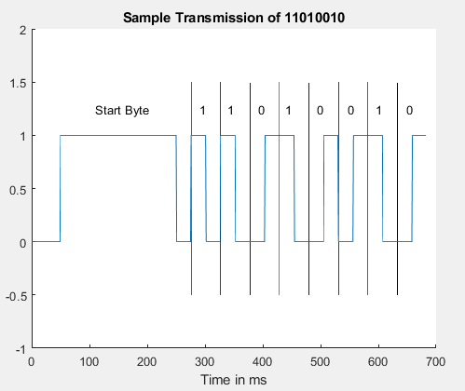
Figure 2 Transmission of a single byte 0xD2
To reduce noise in the received signal due to random fluctuations, a unique waveform is used to send a 0 and 1 as seen in Figure 2. The T sample length used is 50 ms. To start a byte, a pulse of 4*T is sent then brought down to 0 for T/2. Each symbol is of length T with a high and low section split at T/2. A 1 sends a high then low. A 0 sends a low then high. This is to help stabilize the signal by continuously changing the output value. This way even a long sequence of all 0’s or 1’s will still alternate properly.
Each controller shall use interrupts in C and listeners in Java to handle incoming data.

Results

Application

General
4.1.1.1 Tests pass.

Lighting
4.1.1.2.2 Physical light does not turn on, request makes it to the Home Controller.
4.1.1.2 Tests partially failed.

Washer Dryer
4.1.1.3.1 No popup appears
4.1.1.3.3 When a database value for a machine goes from Active->Idle, a notification pops up only when the app is open or running in the background
4.1.1.3 Tests partially failed.

Settings
4.1.1.4 Tests passed.

Logon
4.1.1.5.2 Password textbox does not exist
4.1.1.5.3 Password textbox does not exist
4.1.1.5.6 Password textbox does not exist
4.1.1.5 Tests partially failed

Connection
4.1.1.6.1 No popup appears when not connected to the internet
4.1.1.6.2 No popup
4.1.1.6 Tests failed

Home Controller

Software
4.2.1.1.1 Database only updates when necessary, not every 15+- 0.1 seconds
4.2.1.1.3 No way to tell when physical switch is turned off
4.2.1.1.6Using a no-SQL database language with Firebase
4.2.1.1 Tests partially failed

Hardware
4.2.1.2 Tests pass

Lighting Controller

Software
4.3.1.1.3 Device receives no requests from any source.
4.3.1.1 Tests partially fail

Hardware
4.3.1.2 Tests pass

Washer Dryer Controller

Software
        - No communication with the Home Controller is made.
4.4.1.1 Tests partially fail

Hardware
4.4.1.2 Tests pass

Discussion
Many of the following failing tests are due to design changes and time limitations:
4.1.3 Washer Dryer failed due to no pop-ups and notification behavior.
Pop-ups were deemed unnecessary as the user can define beforehand if they want the notification to appear. The notification only appears if the app is running in the background. To get the notification to appear any time, additional advanced framework must be created of which I am not aware how to do.
4.1.5 Logon failed as there is no password field.
The user now has the option to log in with their Google account to save the system ID. This allows for a more random system ID that will act like a password and the user will not have to remember the ID.
4.1.6 Connection failed as there is no implementation for when there is no internet access.
I am not sure how to handle when the connection fails and when it would even need to check. There is some framework in place when using the database, but more work will have to be done to handle connection errors.
4.2.1 Home Controller Software failed due to a different database and the physical light switch status.
Firebase was found to already have implementations for all my server needs so this test failure is insignificant. Additional hardware would need to be implemented to detect if current is flowing through the relay.
4.3.1 Lighting Controller Software/Hardware failed because the communication system between this controller and the Home Controller Failed.
The communication system needs more work to become functional. The 433 MHz modules never output or received any signal. This could be due to misunderstandings in how the module is supposed to be wired, or the device brand could be faulty. Communication was tried with two different receiver and transmitters, and no data was ever received.
4.4.1 Washer Dryer Controller failed because the communication system between this controller and the Home Controller failed.
The Washer Dryer Controller failed for the same reason as the Lighting Controller. There is something wrong in the code when attempting to communicate between the systems. The 433 MHz modules were removed, and a single long wire was used to allow the systems to communicate. Even with this hard wiring of the modules, the modules still could not talk to each other.
Each part of the system functions correctly except for the communication system between each home device. While debugging with the microcontrollers, the Lighting Controller could turn on the light when the correct input was given. The Washer Dryer Controller sampled data at the appropriate times and set the machine state at the right time. Each time a controller failed, it was trying to send or receive data from the Home Controller.

Conclusion
Creating an application is very different than programing a chip or doing some signal processing. In all other programing projects, I have done relating to electrical engineering, the scope of the project was only a few simple files. Working in Java has shown me how sometimes it can be a good thing to have systems separated out into several files. Each Java class is in its own file and as a result, there is less clutter in each file as typically, that class only does one job. Building an application has also shown me how user interfaces function when using .xml files. While you can specify specific coordinates for objects, it becomes easier to have the location of objects be defined by nearby reference points to make the display more dynamic.
Working in Java has also shown me how to use large APIs to make my project function. I am currently using Firebase, Google’s login, and the Raspberry PI IO APIs to accomplish advanced tasks. Prebuild systems can make the final project less clunky as often times the API is more optimized than what the programmer can create.
Creating a real time communication system offered a new challenge. Previously, all communication systems were built in programs like MATLAB where speed doesn’t matter, and all data is local. Creating a real time system involves using interrupt procedures to accomplish the same structure as a MATLAB simulation.
More work needs be done to get the communication system running for each of the controllers. To test logic, the wireless modules will be replaced by wires to make sure the correct data is sent and received. Once the communication format is correct, work can be done to implement the wireless 433 MHz modules. More information is needed on the transmitter module. The transmitter seems to have duplicate pins with three ground, two Vcc, and two data lines. The documentation for the module says to short all duplicate lines together from the microcontroller [2]. Additional research will need to be done to either get better documentation for the transmitter or use a different transmitter.

References
[1] | "Distribution dashboard | Android Developers," Android Developers, 2019. [Online]. Available: https://developer.android.com/about/dashboards. [Accessed 29 April 2019].
[2] | Holy Stone Enterprise Co., Ltd, "sparkfun," [Online]. Available: https://www.sparkfun.com/datasheets/Wireless/General/MO-RX3400.pdf. [Accessed 1 May 2019].
[3] | Firebase, "Firebase Android Documentation," Firebase, [Online]. Available: https://firebase.google.com/docs/android/setup?authuser=1. [Accessed 1 May 2019].
[4] | R. Savage and D. Sendula, "The Pi4J Project," Pi4J, 2019. [Online]. Available: https://pi4j.com/1.2/index.html. [Accessed 1 May 2019].

